**METHODS**

*Study sites*.—Stonecats were collected from three Lake Champlain tributaries. The Great Chazy River which originates near Ellenburg, New York, and empties into northern Lake Champlain (44.93236N; 73.38537W) is approximately 86 km long and drains a watershed of 790 km2. The LaPlatte River is 24-km long, drains a 138 km2 watershed (Pelton et al. 1998), and enters Lake Champlain in Shelburne Bay (44.39959N; 73.23385W). The Missisquoi River is 130 km long, drains a watershed of 2,200 km2 in northern Vermont and sections of Quebec, Canada, and enters Lake Champlain in Missisquoi Bay (44.99630N; 73.15729W).

*Data Collection*.—Stonecats were collected from the lower 33 km of the Great Chazy River on 17-19 October 2012 as mortalities from a TFM lampricide treatment conducted on 16-18 October 2012. Additional specimens were collected from the Great Chazy River on 8-9 August 2011 and 15 November 2011, NY as part of a bioassay study (M. Calloway, U.S Fish and Wildlife Service, unpublished data). Stonecats were frozen as quickly as possible and returned to the lab where they were thawed and measured for standard (SL) and total lengths (TL) to the nearest mm before the dorsal spine was removed by cutting it just above the articulation point (Buckmeier et al. 2002; Manny et al. 2014; Fischer and Koch 2017).

Spines were placed in boiling water to remove excess skin flesh and then allowed to dry before being set in epoxy. One or two 0.5-mm sections were cut from the spine using a BuehlerTM low-speed isomet saw (Buehler, Lake Bluff, Illinois). Thin sections were glued to slides for viewing under an Olympus SZX9 dissecting microscope using fiber optic transmitted light. Annuli were defined by the opaque zones on the sectioned spine. Three readers blind to the size of the fish used this criterion to independently estimate the age of each fish. The three readers attempted to reach a consensus age if there were discrepancies among their estimated ages. If a consensus could not be reached then the spine was removed from further analysis.

Stonecats were collected from the LaPlatte and Missisquoi rivers from June to October 2012, May to October 2013, and June to October 2014 using backpack electrofishing and minnow traps. Backpack electrofishing used 200 volts, 20-30 Hz, and a 20-40% duty cycle with an effort that ranged from 26 to 247 minutes, with a mean effort of 86 minutes (SD = XXX). Minnow traps were 42 cm long and 23 cm diameter with 2.5 cm openings at each end and 0.6 cm square meshed sides. Minnow traps were set overnight (18-24 h soak time) in gangs of three or four attached to a single weight. Further sampling details are in Puchala et al. (2016).

Captured Stonecats not experiencing obvious distress were anesthetized with 100 mg/L MS-222. Each individual was measured for TL to the nearest mm and all Stonecats greater than ~90 mm TL had a passive integrated transponder (PIT) tag (Biomark, Boise, Idaho, 134-kHz, 8.4 mm x 1.44 mm) inserted into the peritoneal cavity. Individuals were examined for the presence of a PIT tag after the first sampling event.

*Data analysis.*— Growth of Stonecats collected from the Great Chazy River was summarized with the traditional von Bertalanffy growth model (Beverton and Holt 1957):

$$L_{t}=L_{∞}\left(1-e^{-K\left(t-t_{0}\right)}\right)$$

where *Lt* is the observed TL at time (or age) *t*, *L*∞ is the asymptotic mean TL, *K* is the Brody growth coefficient, and *t0* is the theoretical time when the mean TL is zero (Ogle et al. 2017). We used fractional ages in this model to adjust for our fish being collected at various times throughout the growing season (Ogle et al. 2017). We assumed that annual growth on the spine commenced on June 1 (Carlson 1966) and was completed by November 1. Thus, the adjusted age was equal to the number of observed annuli for fish collected before June 1, was one more than the number of observed annuli for fish collected after November 1, and was the number of observed annuli plus the fraction of the growing season completed for fish captured between June 1 and November 1. We chose not to use a growth model with a seasonal component (e.g., Somers [1988]) for fish collected from the Great Chazy River because sampling dates were concentrated on only a few days in a year.

Growth of Stonecats collected from the LaPlatte and Missisquoi rivers could not be summarized with the traditional von Bertalanffy growth function because age for these fish could not be estimated. Rather we summarized growth of Stonecats from these two rivers with the traditional von Bertalanffy growth model modified by Francis (1988) for use with mark-recapture data and including a seasonal component:

$$ΔL=\left(\frac{{L_{2}g}_{1}-{L_{1}g}_{2}}{g_{1}-g_{2}}-L_{m}\right)\left(1-{\left[1+\frac{g_{1}-g_{2}}{L_{1}-L_{2}}\right]}^{ΔT+θ_{2}-θ_{1}}\right)$$

where

$$θ_{i}=\frac{u\sin\left(2π\left(t_{i}-w\right)\right)}{2π}$$

In this model, *Lm* is the TL at the time of marking, *L* is the change in TL between marking and recapture, *t1* and *t2* are the marking and recapture times (years), *t* is the change in time (years) between marking and recapture, *g1* and *g2* are parameters that represent the mean annual growth rate or increment at *L1* and *L2* (which are chosen by the analyst), *w* is a parameter that represents the time of year when the growth rate is maximum, and *u* is a parameter that describes the extent of the seasonal variation in growth (i.e., *u*=0 represents no seasonal variability in growth). For fish that were recaptured multiple times, we treated each interval between recaptures as independent capture-recapture (C-R) events (Ogle 2017). For example, if a fish was captured three times, we considered the interval from marking to the first recapture as one C-R observation and the interval from the first to second recapture as a separate C-R observation. Capture-recapture events based on observations within 7 d of each other were excluded from further analysis under the assumption that any growth that occurred in this short period was minimal and likely less than measurement error. We also combined data from the LaPlatte and Missisquoi rivers because the small sample size in the Mississquoi River precluded modeling growth for that river alone. We modeled a season component to growth with these data because fish were collected on many dates within each year, rather than only a few date as with the Great Chazy River data.

Both growth models were fit using the “port” algorithm in the nls() function in R v3.5.1 (R Core Team 2018). The *g1*, *g2*, and *u* parameters were constrained to be positive and the *w* parameter was constrained to be between 0 and 1. All other parameters were unconstrained in model fitting. Three different starting values and two other algorithms (Gauss-Newton in the nls() function and the Levenburg-Marquardt in the nlsLM() function from the minpack.lm package v1.2-1 [Elzhov et al. 2016]) were used to determine the robustness of parameter estimates to staring values and model fitting algorithms (Ogle et al. 2017). Bootstrap confidence intervals for model parameters were estimated from 999 bootstrapped samples using the nlsBoot() function from the nlsTools package v1.0-2 (Baty et al. 2015) as described in Ogle (2016).

Parameter estimates could not be compared between locations because different models were required for each location. Thus, we compared growth between locations by predicting annual growth increments for fish of various initial lengths. Predicted annual growth increments at two lengths (*L1* and *L2*) are the *g1* and *g2* parameter from the Francis model. Thus, we refit this model at several different values of *L1* and *L2* to better represent growth of this population throughout the range of lengths. Annual growth increments were predicted from the traditional model by first computing the mean length at several ages and then finding the differences between these lengths. Bootstrap confidence intervals were constructed for both the predicted mean lengths and increments. These results were compared to mean lengths and corresponding increments reported for Stonecats in the literature (Carlson 1966, Paruch 1979, Gibson 1985). Some of the literature results were converted from SL to TL using results from a linear model fit to our measurements of SL and TL on fish collected from the Great Chazy River.

**RESULTS**

A total of 177 Stonecats from the Great Chazy River were aged from spines. Age-classes ranged from 0 (young-of-the-year) to 5 with most fish age-0 (49%) and only five (3%) fish age-4 or older. Stonecats from Great Chazy River ranged from 44 to 193 mm TL, with a mean TL of 114 (SD = 41.5) mm. The SL-TL relationship is TL=1.239+1.166SL (r2 = 0.996). Parameter estimates (with 95% confidence intervals) for the traditional von Bertalanffy growth function are 172 (160 - 193) for *L*∞, 0.79 (0.51 - 1.15) for *K*, and 0.13 (-0.15 – 0.33) for *t0* (Figure 1).

A total of 1311 and 131 Stonecats were tagged in the LaPlatte and Missisquoi rivers, respectively. Of these, 133 (10%) and 23 (18%) were recaptured at least once. In both rivers together, 24 fish (15%) were recaptured twice and 2 fish (1%) were captured three times. Thus, 184 paired C-R events were observed, though 18 (10%) of these were within 7 days of each other and were removed from further analysis. Of the remaining C-R events, 62% were in the same year, 37% were in the following year, and 1% were two years later (Figure 2). Stonecats from the LaPlatte and Mississquoi rivers ranged from 87 to 189 mm TL at the time of marking, with a mean of 133 (SD = 22.5) mm. One fish was 192 mm at the time of recapture. Parameter estimates for the modified von Bertalanffy growth function are 34.1 (32.4 – 35.6) for *g1* at *L1*=100, 18.3 (17.0 – 19.6) for *g2* at *L2*=150, 0.55 (0.52 – 0.58) for *w*, and 2.50 (2.26 – 2.77) for *u*.

Annual growth of Stonecats at lengths that corresponded to ages for the Great Chazy River was somewhat less in the LaPlatte and Missisquoi rivers for age-1 fish, similar for age-2 and age-3 fish, and somewhat greater for age-4 and age-5 fish (Figure 3). Growth of the Stonecats in this study was greater than that for streams in Wisconsin (Paruch 1979), Ohio (Gilbert 1953), and the Vermillion River (South Dakota; Carlson 1966) for at least the first two years of life. However, fish from the Lake Champlain tributaries was substantially less than that described for Stonecats from Lake Erie (Gilbert 1953).

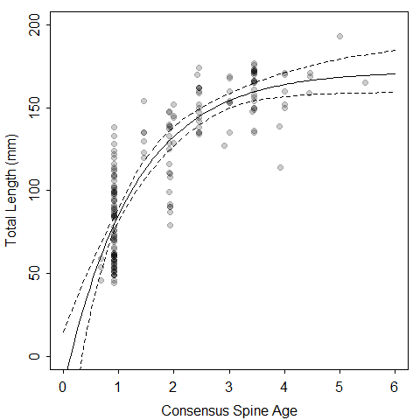

Figure 1. Fit (solid line), with 95% confidence bounds (dashed lines), of the traditional von Bertalanffy growth function to total lengths and ages of Stonecats collected from the Great Chazy River, New York in 2011 and 2012. Observations are plotted with a semi-transparent color such that darker points represent more observations.

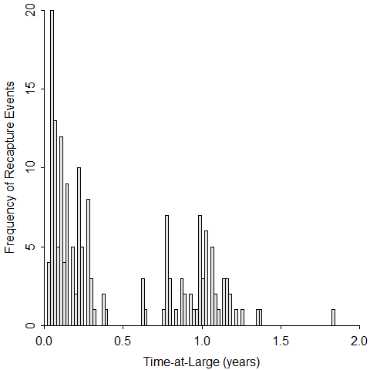

Figure 2. Histogram of times-at-large for Stonecats captured and recaptures from the LaPallette and Mississquoi rivers Vermont in 2012-2014. Each bar in the histogram is seven days wide. Note that 18 events where the time between captured and recapture events was less than seven days are not include.

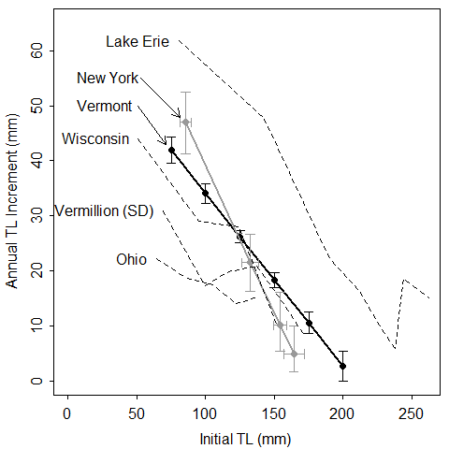

Figure 3. Annual total length (TL) increment versus initial total length for the two locations of this study (New York and Vermont) and for four studies from the literature (Lake Erie [Gilbert 1953], Wisconsins streams [Paruch 1979], Vermillion River [Carlson 1966], and Ohio streams [Gilbert 1953]). The Vermont results are shown with 95% bootstrap confidence intervals for the annual increment for parameters in the von Bertalanffy growth model modified by Francis (1988). The New York results shown 95% bootstrap confidence intervals for both the annual increment and the initial total length as predicted from the traditional von Bertalanffy growth model.

**REFERENCES**

Baty, F., C. Ritz, S. Charles, M. Brutsche, J. P. Flandrois, and M. L. Delignette-Muller. 2015. A toolbox for nonlinear regression in R: the package nlstools. Journal of Statistical Software 66(5):1-21.

Becker, G. C. 1983. Fishes of Wisconsin. University of Wisconsin Press, Madison, WI. 1052 pp.

Beverton, R. J. H., and S. J. Holt. 1957. On the dynamics of exploited fish populations. United Kingdom Ministry of Agriculture; Fisheries.

Carlson, D. R. 1966. Age and growth of the stonecat, *Noturus flavus* Rafinesque, in the Vermillion River. Proceedings of the South Dakota Academy of Sciences 45:131-137.

Elzhov, T. V., K. M. Mullen, A.-N. Spiess, and B. Bolker. 2015. minpack.lm: R interface to the Levenberg-Marquardt nonlinear least-squares algorithm found in MINPACK, plus support for bounds. R package.

Fischer, J. R. and J. D. Koch. 2017. Fin rays and spines. Pages 173-187 *in* M. C. Quist and D. A. Isermann, editors. Age and Growth of Fishes: Principles and Techniques. American Fisheries Society, Bethesda, MD.

Francis, R. I. C. C. 1988. Maximum likelihood estimation of growth and growth variability from tagging data. New Zealand Journal of Marine and Freshwater Research 22:42-51.

Ogle, D. H. 2016. Introductory fisheries analysis with R. Chapman & Hall/CRC Press, Boca Raton, Florida.

Ogle, D. H., T. O. Brendan, and J. L. McCormick. 2017. Growth estimation: growth models and statistical inference. Pages 265-359 *in* M. C. Quist and D. A. Isermann, editors. Age and Growth of Fishes: Principles and Techniques. American Fisheries Society, Bethesda, MD.

Paruch, W. 1979. Age and growth of Ictaluridae in Wisconsin. M.Sc. Thesis, University of Wisconsin – Stevens Point. 97 pp.

R Development Core Team. 2017. R: a language and environment for statistical computing. R Foundation for Statistical Computing. Vienna, Austria. URL <http://R-project.org>.

Somers, I. F. 1988. On a seasonally oscillating growth function. Fishbyte 6:8-11.